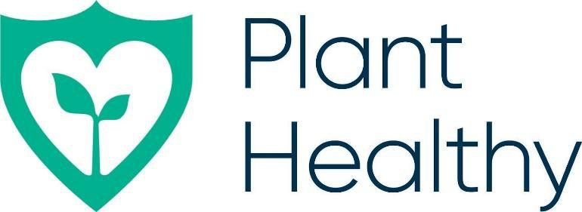

Plant Healthy Certification Scheme

Group Scheme Option C Guide

Overview
The Plant Healthy Certification Scheme Group Scheme Option C (a multisite auditing process) allows a group of organisations, where all sites operate as separate entities, to be audited annually against the Plant Health Management Standard (PHMS) by an Internal Auditor. The square root of the number of sites (which provides a representative sample of the sites), are also audited annually by an independent Certification Body – this independent external audit includes a review of all the Internal Auditor’s reports.

Eligibility
With the exception of the lead organisation, only organisations in Bands 1 and 2 as defined in the current Plant Healthy membership fees table are eligible to become members of a Plant Healthy Group Scheme under Option C.
A group can include any type of organisation that is within the scope of Plant Healthy certification i.e. plant nurseries, traders, garden centres, retailers, landscapers, arborists and gardens.
There must be a minimum of 4 organisations in a group. There is currently no limit on the maximum number in a group.

Pre-Application
Prior to application, the lead business/organisation must appoint a Group Scheme Leader and Internal Auditor (these can be the same person). This person(s) must complete formal online training provided by Plant Healthy Ltd on the requirements of the PHMS and auditing procedures so that they fully understand what is required of the group. The lead organisation will be a member of the Group and as such is subject to the same certification requirements as the other Group Members.
Please see Appendix 1 for a copy of the Option C Group Scheme Membership Agreement Template. This document should be in place for each Group Member by the time the first external audits are due.
Group Scheme Leader Role Requirements:
The Group Scheme Leader will have the authority and ability to manage the Group, including collecting and analysing data from all the Group Sites.
The Group Scheme Leader’s responsibilities include:
- Developing and maintaining a list of all Group Members as part of a system for monitoring all members on an annual basis (as a minimum)
- Maintaining Group Membership Agreements (see Appendix 1)
- Developing and reviewing group scheme documents including operating procedures and templates used across the group
- Training of group scheme members in Plant Healthy requirements and processes
- Appointing an internal auditor (if required)
- Applying for group certification
- Collecting fees from group members
- Payment of fees to Plant Healthy and the Certification Body
- Keeping group members updated on any new Plant Healthy Certification Scheme requirements and documents as they arise.
- Undertaking management reviews of each group member in terms of their maintaining compliance with the PHMS
- Complaints handling
- If there is no separate Internal Auditor, planning and undertaking internal audits of all sites within the group on an annual basis (see below for more information on internal audits)
- If there is no separate Internal Auditor, evaluation of internal and external audit results
- If there is no separate Internal Auditor, ensuring that any corrective actions from audits are carried out promptly.
- Advising Group Members on the status of their certification and send certification marks to the relevant Group Members once received from the CB.
Internal Auditor Role Requirements (if separate to the Group Scheme Leader):
- Undertaking training in the PHMS & internal auditor training
- Planning and undertaking internal audits of all sites within the group on an annual basis (see below for more information on internal audits)
- Evaluation of internal audit results
- Ensuring that corrective actions arising from non-conformances found at internal audit are carried out

Application
The Group Scheme Leader should apply to their chosen Certification Body as an Option C Group scheme, listing all sites to be included. Please note that, should additional sites be required once the group has been certified, these sites will be required to complete a full Plant Healthy audit before being added to the group’s certificate.
Once the Certification Body has confirmed that the Plant Healthy scheme membership fee has been paid all sites will be added to the applicants list on the Plant Healthy directory.

Internal Audit

Internal audits can be completed before or after the initial application to the Plant Healthy Certification Scheme. However, Plant Healthy rules state that external audits should be carried out within 60 days of application, therefore all internal audits must be completed within this time frame.

Internal audits are carried out using the same checklist of PHMS requirements that is used by the external auditors. Any non-conformances raised at the internal audit will need to be rectified and evidenced to the internal auditor prior to the external audit being completed.

An internal audit of each site that is part of the group must be undertaken annually.

External Audit
An external auditor will be appointed by the chosen Certification Body. In the first year, a representative sample of sites will be selected at random where the number of sites to be audited is the square root of the total number of sites. The group lead site (‘group HQ’) does not need to be externally audited each year provided it is an operational site. For example, for a group of 4 sites in total this would mean that 2 sites would receive an external audit in the first year and the remaining 2 sites would receive an external audit the following year and so on. Sites are audited against the full PHMS. The auditor will also include a review of all internal audit reports and any corrective actions.
Any non-conformances raised at the external audit should be rectified by the group member that incurred them and evidence of rectification sent by the Group Scheme Leader to the Certification Body for review. The Certification Body will undertake a technical review of the audit report and any non-conformance corrective evidence before certifying the report.
All group sites must complete any non-conformance corrective actions before the group certificate can be issued. If any site fails to complete any non-conformances arising at the internal audit this will be raised at the external audit. If any site fails to complete non-conformances at an external audit then the entire group’s certification will be on hold until the outstanding non-conformances are addressed. The Group Scheme Leader is responsible for ensuring that outstanding non-conformances are addressed promptly.
Upon certification each group member will be issued with a unique certification number and certificate and access to the Plant Healthy logo which can be used across any branding or marketing material.

Group Scheme Process Summary
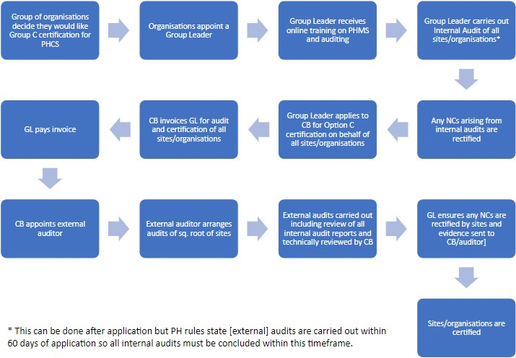

Fees
Each group member must pay the fee due for Plant Healthy membership at the time of the initial application for certification and on renewal of certification thereafter. This fee is based on the member’s turnover band.
The organisation with the role of Group Scheme Leader will have their Plant Healthy membership fee discounted by 50%.
The Plant Healthy membership fee does not include Certification Body fees and expenses which are arranged directly with the Certification Body in accordance with the scheme rules. Each Group Member will be responsible for paying their share of the external audit fees, regardless of whether they are externally audited in any year or not.

The Group Leader is responsible for the collection and payment of Plant Healthy membership and Certification Body fees. Any fees that may be charged to cover the costs of the internal audits is a decision for the individual groups themselves.

Appendix 1: Option C Group Scheme Membership Agreement Template
- Introduction
  - This membership agreement is between the organisational Leader of the Group [insert Organisation Name] (hereinafter referred to as ‘the Group Scheme Leader’) and the following Group Member, [enter member’s name and membership reference number here], hereinafter referred to as ‘the Group Member’ and is provided to enable understanding of the roles and responsibilities of the Group Scheme Leader and the roles and responsibilities of the Group Member.
2 Group Scheme Leader
  - The Group Scheme is operated through [enter company name if any] with company number [enter company number if any], and with its registered office at [enter company address], as the Group Scheme Leader and accountable body for the management of the group, and as a member of the group themselves. The Group Scheme has the Plant Healthy application number [enter Group scheme Plant Healthy application reference number here].
  - The Group Scheme Leader has appointed [enter group leader’s name] as the current named Group Scheme Leader. The contact details for all enquiries relating to the Group Scheme are:
[enter the group leader’s contact details (telephone and email)]

  - The roles and responsibilities of the Group Scheme Leader:
    - Developing and maintaining a list of all Group Members as part of a system for monitoring all members on an annual basis (as a minimum)
    - Maintaining group membership agreements
    - Developing and reviewing Group Scheme Documents including operating procedures and templates used across the Group
    - Training of Group Members in Plant Healthy requirements and processes
    - Appointing an Internal Auditor (if required)
    - Applying for group certification
    - Collecting fees from Group Members
    - Payment of fees to Plant Healthy and the Certification Body
    - Keeping Group Members updated on any new Plant Healthy requirements and documents
    - Undertaking management reviews of each Group Member in terms of their maintaining compliance with the PHMS
    - Complaints handling
    - If there is no separate Internal Auditor, planning and undertaking internal audits of all sites within the Group on an annual basis
    - If there is no separate Internal Auditor, evaluation of internal and external audit results
    - If there is no separate Internal Auditor, ensuring that any corrective actions from audits are carried out promptly.
    - Advising Group Members on the status of their certification and send certification marks to the relevant Group Members once received from the Certification Body.
- Group Member
3.1 [enter Group Member name or Company] here, whose registered office is at [enter Member correspondence address here], is a member of this Group Scheme with Plant Healthy reference number [enter application ref number here].
  - The Group Member has appointed [enter name of the member contact person here] as their representative and responsible person.
  - Roles and Responsibilities of the Group Member
[Enter member name here] hereby agrees that:

    - Their membership contact details will be kept on a central database held by the Group Scheme Leader for the purposes of the Plant Healthy application.
    - They have read and will comply with the current Plant Health Management Standard requirements (and any future developments/updates).
    - They have read and will comply with the Plant Healthy Certification Scheme Membership Rules
    - They have read and will comply with the Plant Healthy Logo Use
    - To read and agree to comply with any additional Plant Healthy Policy documents and Statements and or updated versions of the Plant Health Management Standard and other documents that may be issued from time to time.
    - To pay the fees due for membership of the group at the time of joining or on renewal. The fees will be set by the Group Scheme for the first 12 months, and these will be reviewed thereafter. Each Group Member will be responsible for paying their share of any audit fees, regardless of whether they are externally audited or not.
    - To comply with the Group Scheme Leader’s requirements for monitoring and auditing procedures to demonstrate your compliance with the Plant Health Management Standard. This includes annual internal audits by the Group Scheme Leader and external audits as required by an appointed auditor.

    - To provide one month’s notice of your intention to leave the group. If you leave the group on your own accord and not because of any major on-going compliance issues, you will be entitled to a refund of the Group Scheme fees where relevant [insert terms here]. Plant Healthy fees, including membership fees, will not be refunded.

    - If you can no longer demonstrate compliance with the Group Scheme or Plant Health Management Standard requirements, you will be deemed to have left the group. The Group Scheme Leader will inform you of this in writing. The Group Scheme Leader will also inform the Certification Body and the other members of the group. As a former member you will no longer be able to use the Plant Healthy logo. Fees, including Plant Healthy membership fees, will not be refunded.
    - To inform the Group Scheme Leader within one month of the acquisition of a new business or significant change to your procedures.
    - First attempt to resolve any complaints about a Group Scheme Leader via the Group Scheme complaints process before escalating to the Certification Body if they are not resolved.
- Confidentiality
  - Other than the listing of the Group Member contact details and reference numbers, all business information provided by the Group Member to the Group Scheme Leader during the application and certification process will be treated in strict confidence and not shared with a third party without prior agreement, except as outlined in 4.1.1 (below).
    - The Group Member agrees that the Group Scheme Leader will share relevant information provided by the Group Member during the application and certification process with the Certification Body.
  - Appropriate audit results established during a complaint investigation may be passed to the Certification Body, the Group Member and Group Member’s customer(s) for the sole purpose of complaint resolution.
- Duration of this agreement
5.1 This agreement is for 12 months and is made on [enter date here] and will expire on [enter date here] at which point a renewal of the agreement is required if the Group Member’s certification is to continue.

- Declaration
I hereby consent to the requirements of becoming a member of this Group Scheme as set out in this membership agreement and to comply with the Plant Healthy Scheme Membership Rules

Signed by the Group Scheme Leader, for and on behalf of the Group Scheme [enter Group Scheme Name]

Name:

Signed:

Dated:

Signed for and on behalf of [enter member name]

Name:

Signed:

Dated:

All the definitions and processes used within the multisite auditing procedure are in accordance with the Mandatory Documents provided by the International Accreditation Forum
The list of group scheme members must include the following details: - Name and contact details of businesses - Contact responsible for membership within that business - Location of nursery business - Number and size of sites that each group member has - Number and type of trees/plants produced on an annual basis
This number can be changed to the member’s Group Scheme Certification Number once certification is achieved.
This number can be changed to the member’s Group Scheme Certification Number once certification is achieved.
Available on request from the Certification Body
Available on request from the Certification Body

